CIS 375 Final Project  
Due Date: Wednesday May 3, 2017 @ 11:59 pm

Overview  
For the final project in CIS 375 you will use an accumulation of the topics we covered in class. For most of the project it will focus on the use of the database and validation controls. Some of the project will be like others, however there is parts of it that will utilize your own creativity in putting it together.

The project will utilize a site master, bootstrap, validation controls, server controls, authorization topics, and databases to highlight just a few of the things included.

Project

1. Create a new project
2. Add the TechSupport.mdf file to your App_Data Folder
3. Create an Default.aspx page and add text and images to make it look appropriate
4. Create an About.aspx page and add text and images to make it look appropriate
5. Create an Contact.aspx page and add text and images to make it look appropriate
6. Make sure that your site has ssl enabled and that you update the secure and unsecure path in your web.config file
7. Make sure that your site uses friendly urls and update the appropriate files and menu items to make that work.
8. Create an account management page that allows you to do the following
   1. Create Roles – This will utilize the AspNetRoles Table
   2. Allow you to select a user and assign them a role
   3. You can add more to this and format it as needed but by the end of the project you should have at least 3 roles – Admin, Customer, Technicians.
   4. Create 3 different accounts and assign them each a role. You should make it easy and do something like [admin@something.com](mailto:admin@something.com) Password1! and so on so I can easily test things.
9. Review the tables that are in the TechSupport database.
   1. Create pages that utilize the following views
      1. GridView
      2. DataList
      3. FormsView
      4. DetailsView
      5. ListView
   2. All tables should be represented somewhere in your site
   3. Views should be searchable based off of other tables or specific data. For example, I should be able to search customers by their state.
   4. Utilize the Edit and Insert features of the views.
      1. Make sure all appropriate error checking and validation is in place
      2. Make sure all server controls are appropriately formatted and utilize the correct control as needed.
   5. Use LoginViews that allow only certain roles to be able to see certain things. For example, a customer shouldn’t be able to edit items, but an admin or technician should.
10. Create custom error pages and have them be used appropriately.
11. Create something that will email the user something.
12. Add other pages as you see appropriate and content as needed.
13. Utilize Bootstrap libraries to make things look good.
14. Utilize past assignments and examples to give you ideas on what to do.

## The design of the TechSupport database

The TechSupport database is used to track technical support incidents for a small software company named SportsPro. It consists of the six tables shown in the diagram that follows. The main table is the Incidents table, which contains one row for each technical support incident. Each row in the Incidents table is related to one row in the Customers table, which contains information about the company’s customers; one row in the Products table, which contains information about the company’s products; and one row in the Technicians table, which contains information about the company’s technical support staff members. In addition, a table called Registrations keeps track of the products that are registered to each customer, and the States table contains state and zip code information.

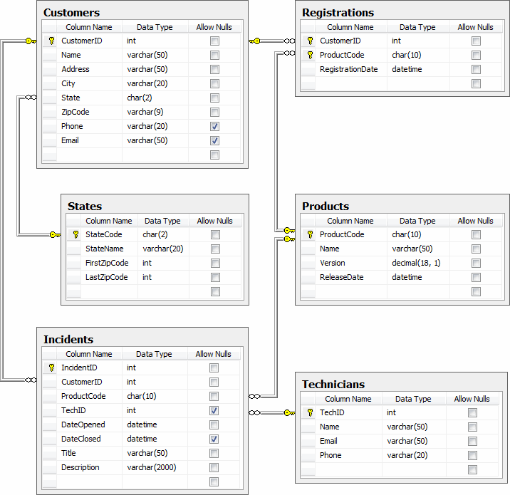

In addition to the column properties shown above, you should know that the CustomerID, IncidentID, and TechID columns in the Customers, Incidents, and Technicians tables are identity columns. So, the values of these columns are set automatically when new rows are added to these tables.

Example of Customers data

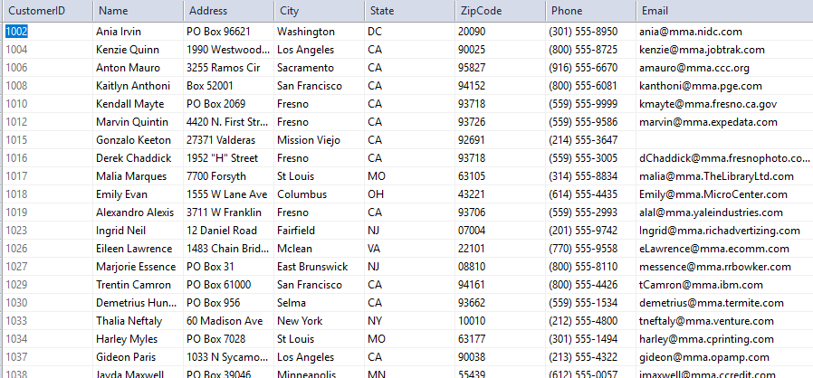

Incident Table

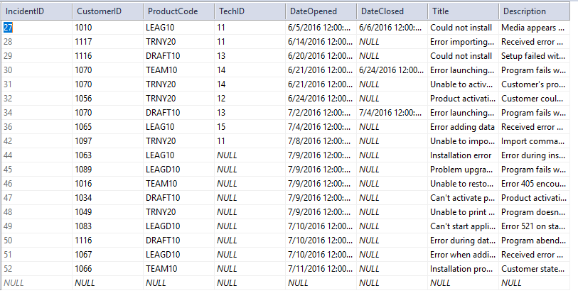

Products

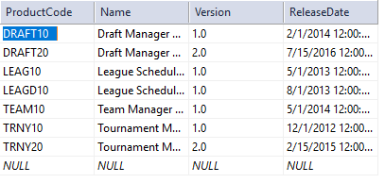

Registrations

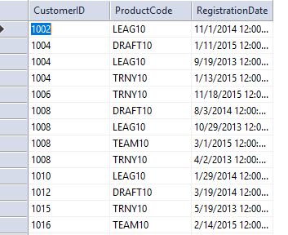

States

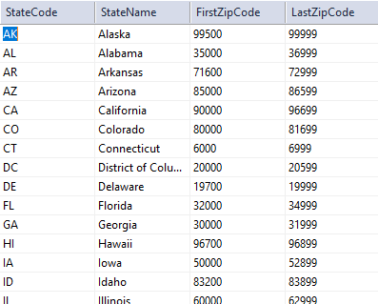

Technicians

